Brian Chan

CISC 3140 – MW2

Assignment 2b

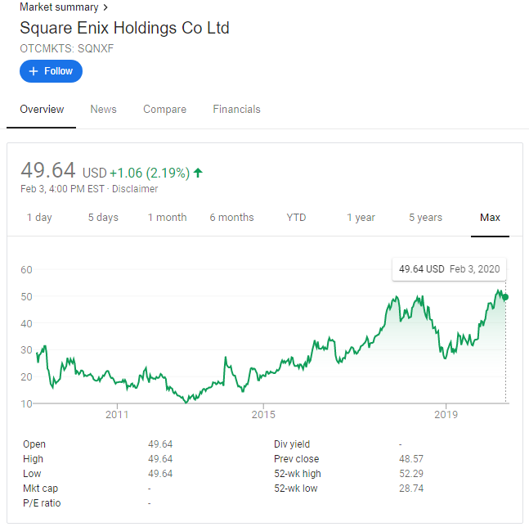

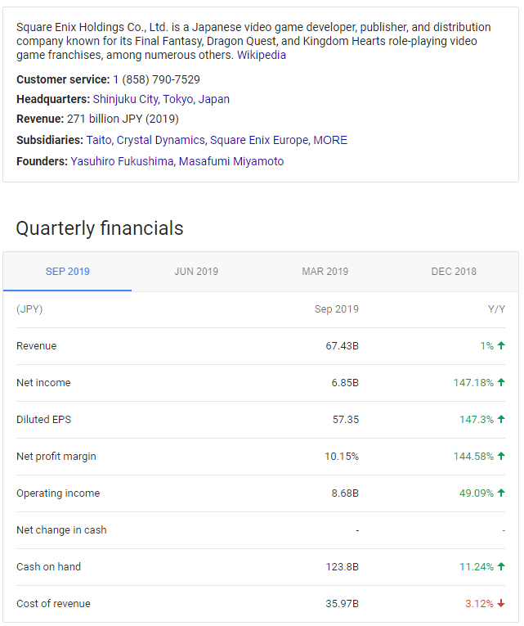

**Corporate Philosophy**

**To spread happiness across the globe by providing unforgettable experiences**

This philosophy represents our company's mission and the beliefs for which we stand.

Each of our customers has his or her own definition of happiness.  
Square Enix provides high-quality content, services, and products to help those customers create their own wonderful, unforgettable experiences, thereby allowing them to discover a happiness all their own.

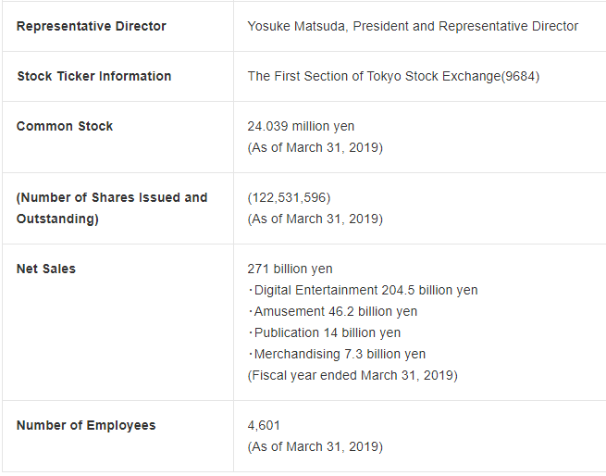

**Careers at Square Enix**

Square Enix Ltd. develops, publishes, distributes and licenses SQUARE ENIX®, EIDOS® and TAITO® branded entertainment content in Europe and other PAL territories as part of the Square Enix group of companies. Square Enix Ltd. also has a global network of leading development studios such as Crystal Dynamics® and Eidos Montréal®. The Square Enix group of companies boasts a valuable portfolio of intellectual property including: FINAL FANTASY®, which has sold over 144 million units worldwide; DRAGON QUEST®, which has sold over 78 million units worldwide; TOMB RAIDER®, which has sold over 74 million units worldwide; and the legendary SPACE INVADERS®. Square Enix Ltd. is a London-based, wholly owned subsidiary of Square Enix Holdings Co., Ltd.

According to a recent article on <https://venturebeat.com/2020/02/04/playstation-sales-down-and-thats-great/> low sales has contributed to development teams being compacted from 11 teams to 4.

Detailed Annual Report 2019: <https://www.hd.square-enix.com/eng/assets/pdf/ar_2019en.pdf>

From Wikipedia:

## **Corporate structure[**[**edit**](https://en.wikipedia.org/w/index.php?title=Square_Enix&action=edit&section=6)**]**

On October 1, 2008, Square Enix transformed into a [holding company](https://en.wikipedia.org/wiki/Holding_company) and was renamed to Square Enix Holdings. At the same time the gaming, contents, and publishing businesses were transferred to a spin-off named Square Enix, sharing the same corporate leadership and offices with the holding.[[12]](https://en.wikipedia.org/wiki/Square_Enix#cite_note-CorpHistory-12)[[48]](https://en.wikipedia.org/wiki/Square_Enix#cite_note-company_outline-48)[[49]](https://en.wikipedia.org/wiki/Square_Enix#cite_note-company_outline_japanese-49) The primary offices for Square Enix and Square Enix Holdings are in the Shinjuku Eastside Square Building in [Shinjuku](https://en.wikipedia.org/wiki/Shinjuku), [Tokyo](https://en.wikipedia.org/wiki/Tokyo).[[48]](https://en.wikipedia.org/wiki/Square_Enix#cite_note-company_outline-48)[[50]](https://en.wikipedia.org/wiki/Square_Enix#cite_note-50)

### Development organization**[**[**edit**](https://en.wikipedia.org/w/index.php?title=Square_Enix&action=edit&section=7)**]**

After the merger in 2003, Square Enix's development department was organized into eight Square and two Enix Product Development Divisions (開発事業部, *kaihatsu jigyōbu*), each focused on different groupings of games.[[51]](https://en.wikipedia.org/wiki/Square_Enix#cite_note-vjump-51)[[52]](https://en.wikipedia.org/wiki/Square_Enix#cite_note-rpgfan-52)[[53]](https://en.wikipedia.org/wiki/Square_Enix#cite_note-53) The divisions were spread around different offices; for example, Product Development Division 5 had offices both in Osaka and Tokyo.[[51]](https://en.wikipedia.org/wiki/Square_Enix#cite_note-vjump-51)

According to Yoichi Wada, the development department was reorganized away from the Product Development Division System by March 2007 into a project-based system.[[54]](https://en.wikipedia.org/wiki/Square_Enix#cite_note-54)[[55]](https://en.wikipedia.org/wiki/Square_Enix#cite_note-55) Until 2013, the teams in charge of the [*Final Fantasy*](https://en.wikipedia.org/wiki/Final_Fantasy) and [*Kingdom Hearts*](https://en.wikipedia.org/wiki/Kingdom_Hearts) series were still collectively referred to as the 1st Production Department (第1制作部, *dai-ichi seisakubu*).[[56]](https://en.wikipedia.org/wiki/Square_Enix#cite_note-56)[[57]](https://en.wikipedia.org/wiki/Square_Enix#cite_note-FNCdevelopers-57)[[58]](https://en.wikipedia.org/wiki/Square_Enix#cite_note-fourteen-58) The 1st Production Department was formed from the fall 2010 combination of Square Enix's Tokyo and Osaka development studios, with [Shinji Hashimoto](https://en.wikipedia.org/wiki/Shinji_Hashimoto) as its corporate executive.[[59]](https://en.wikipedia.org/wiki/Square_Enix#cite_note-59)

During December 2013, Square Enix's development was restructured into 12 Business Divisions.[[60]](https://en.wikipedia.org/wiki/Square_Enix#cite_note-60)[[61]](https://en.wikipedia.org/wiki/Square_Enix#cite_note-%E7%AC%AC8-12%E3%83%93%E3%82%B8%E3%83%8D%E3%82%B9%E3%83%BB%E3%83%87%E3%82%A3%E3%83%93%E3%82%B8%E3%83%A7%E3%83%B3-61) The former Twitter account of the 1st Production Department is now used to distribute information on the games developed by Business Divisions 1 to 4.[[62]](https://en.wikipedia.org/wiki/Square_Enix#cite_note-62)[[63]](https://en.wikipedia.org/wiki/Square_Enix#cite_note-63)

Square Enix announced on a financial results conference with their investors that their eleven Business Divisions would be consolidated into four in 2020.[[64]](https://en.wikipedia.org/wiki/Square_Enix#cite_note-64) Naoki Yoshida who was previously the Head of Business Division 5, now will be the head of Third Development Division.[[65]](https://en.wikipedia.org/wiki/Square_Enix#cite_note-65)

### Business model**[**[**edit**](https://en.wikipedia.org/w/index.php?title=Square_Enix&action=edit&section=8)**]**

*See also:*[*Localization of Square Enix video games*](https://en.wikipedia.org/wiki/Localization_of_Square_Enix_video_games)

The [business model](https://en.wikipedia.org/wiki/Business_model) of Square Enix is centered on the idea of "polymorphic content", which consists of developing franchises on multiple potential hardware or media rather than being restricted by a single gaming platform.[[66]](https://en.wikipedia.org/wiki/Square_Enix#cite_note-66) An early example of this strategy is Enix's [*Fullmetal Alchemist*](https://en.wikipedia.org/wiki/Fullmetal_Alchemist) manga series, which has been adapted into two anime television series, two movies, and several novels and video games.[[67]](https://en.wikipedia.org/wiki/Square_Enix#cite_note-67) Other polymorphic projects include the [*Compilation of Final Fantasy VII*](https://en.wikipedia.org/wiki/Compilation_of_Final_Fantasy_VII), [*Code Age*](https://en.wikipedia.org/wiki/Code_Age), [*World of Mana*](https://en.wikipedia.org/wiki/World_of_Mana), [*Ivalice Alliance*](https://en.wikipedia.org/wiki/Ivalice_Alliance) and [*Fabula Nova Crystallis Final Fantasy*](https://en.wikipedia.org/wiki/Fabula_Nova_Crystallis_Final_Fantasy) subseries.[[68]](https://en.wikipedia.org/wiki/Square_Enix#cite_note-68) According to [Yoichi Wada](https://en.wikipedia.org/wiki/Yoichi_Wada), "It's very difficult to hit the jackpot, as it were. Once we've hit it, we have to get all the juice possible out of it".[[69]](https://en.wikipedia.org/wiki/Square_Enix#cite_note-69) Similar to Sony's [Greatest Hits](https://en.wikipedia.org/wiki/List_of_Sony_Greatest_Hits_games) program, Square Enix also re-releases their bestselling games at a reduced price under a label designated "Ultimate Hits".[[70]](https://en.wikipedia.org/wiki/Square_Enix#cite_note-70)

The standard game design model Square Enix employs is to establish the plot, characters, and art of the game first.[[71]](https://en.wikipedia.org/wiki/Square_Enix#cite_note-wiiware-71) Battle systems, field maps, and [cutscenes](https://en.wikipedia.org/wiki/Cutscenes) are created next.[[71]](https://en.wikipedia.org/wiki/Square_Enix#cite_note-wiiware-71) According to [Taku Murata](https://en.wikipedia.org/wiki/Taku_Murata), this process became the company's model for development after the success of Square's *Final Fantasy VII* in 1997.[[71]](https://en.wikipedia.org/wiki/Square_Enix#cite_note-wiiware-71) The team size for [*Final Fantasy XIII*](https://en.wikipedia.org/wiki/Final_Fantasy_XIII) peaked at 180 artists, 30 programmers, and 36 game designers, but analysis and restructuring were done to outsource large-scale development in the future.[[72]](https://en.wikipedia.org/wiki/Square_Enix#cite_note-peak-72)

Programming Job Requirements, from <https://apply.workable.com/square-enix/>

#### Requirements

### Knowledge and Experience

### Essential

1. University degree in programming, computer engineering, software engineering or the equivalent
2. Minimum 5 years relevant work experience
3. Significant telecommunications/network or web services programming experience
4. Experience with TCP/IP, sockets
5. Experience with databases (SQL and NoSQL)
6. Experience with QA concepts such as unit and regression tests, and continuous integration

### Desirable

1. Good knowledge of the Xbox live services and PSN (End-user, API and TCR), an asset

### Competencies, Skills and Attributes

### Essential

### **Excellent C++ and Java**

### **Strong JavaScript, HTML**

### **Strong OOD skills**

### **Experience with security mechanism such as: encryption, authentication, secured sockets**

### **An approach oriented toward Client Satisfaction**

### **Capacity to organize your own work**

### **Capacity to be a team player**

### **Maturity to give and receive constructive criticism is expected**

### **Be a good communicator**

### Desirable

1. Cross platform development an asset
2. C# and .Net knowledge an asset

### Other

1. Passion for video games!
2. Open to travel
3. Office based role location

References:

<https://www.google.com/search?q=square+enix+holdings&tbm=fin#scso=_PcE4XqW1HZygytMP6oul4AI5:0>

<https://www.hd.square-enix.com/eng/company/>

<https://en.wikipedia.org/wiki/Square_Enix>

<https://apply.workable.com/square-enix/>